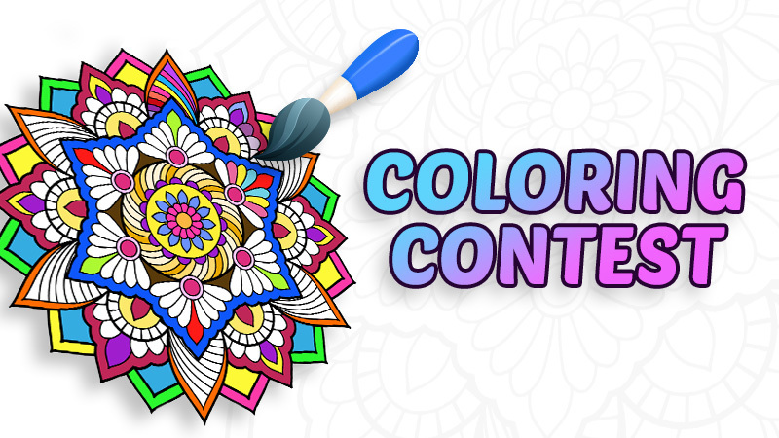
ADULT

If you are 18+, participate in our adult coloring contest. Pick up a special color sheet at the library starting Friday, September 9th. We have copied it on cardstock so different mediums may be used. Return your entry no later than Saturday, September 24th. Patrons will vote for their favorite entry Monday, Sept. 26th through Saturday, Oct. 1st. The winner will be notified on Monday, October 3rd and will win a harvest basket.

